**Interactive Quiz Application using HTML, CSS, JavaScript, Bootstrap, and jQuery**

**Submitted By:**

* *Joshetha SR(2462514)-joshetha.sr@btech.christuniversity.in*
* *Prarthana Puthan Purayil(2462526)-prarthana.puthan@btech.christuniversity.in*
* *Poojaa M(2462525)*[*-poojaa.m@btech.christuniversity.in*](mailto:-poojaa.m@btech.christuniversity.in)

**Course:**  
Frontend UI/UX Design Fundamentals

**Instructor Name:**  
Dhiraj Alate

**Institution:**

Christ University(Kengeri campus)-Bengaluru

**Date of Submission:**  
26/09/2025

**1. Abstract:**

This project focuses on designing and developing an **Interactive Quiz Application** to test users’ knowledge of frontend UI/UX concepts. The primary goal was to build an engaging, user-friendly quiz platform where users can answer multiple-choice questions, receive immediate feedback, and view their final score. The application was built using **HTML, CSS, Bootstrap, JavaScript, and jQuery**, ensuring both functionality and responsiveness across devices. The outcome is a simple, yet effective, learning tool that demonstrates **UI/UX principles** combined with **logical interactivity**, making it useful for students and beginners in web development.

**2. Objectives**

* Design a clean and user-friendly quiz interface.
* Implement multiple-choice questions with real-time score tracking.
* Use JavaScript for quiz logic (answer validation, score calculation).
* Integrate a timer to make the quiz more challenging.
* Ensure responsiveness using Bootstrap grid system.
* Apply UX principles to improve usability and accessibility.

**3. Scope of the Project**

* The project includes **five quiz questions** related to general knowledge.
* Each question is displayed on a separate page, making the navigation clear and structured.
* Score is tracked across all pages using browser **localStorage**.
* A final result page displays the score with a “Congratulations” text and allows quiz restart.
* Focused only on the **frontend** with no server-side/database integration.
* Designed for **desktop, tablet, and mobile** using responsive design principles.

**4. Tools & Technologies Used:**

| **Tool/Technology** | **Purpose** |
| --- | --- |
| **HTML5** | Structure of quiz pages |
| **CSS3** | Styling and layout customization |
| **Bootstrap 5** | Responsive design and layout utilities |
| **JavaScript (ES6)** | Quiz logic and score calculation |
| **jQuery** | DOM manipulation and interactivity |
| **VS Code** | Code editor |
| **Chrome DevTools** | Debugging and testing |

**5. HTML Structure Overview**

* Used semantic tags like <header>, <main>, <section>, and <footer>.
* Divided into **Start Screen**, **Quiz Pages (Q1–Q5)**, and **Result Page**.
* Options implemented as **Bootstrap buttons** for consistency.
* Navigation between questions is handled through JavaScript.

**6. CSS Styling Strategy**

* Used an external stylesheet (style.css) with structured sections.
* **Techniques applied:**
  + Bootstrap grid + utility classes for responsive layout.
  + Custom colors and hover effects for buttons.
  + Flexbox for aligning content centrally.
  + Media queries for small screen optimization.
  + Transitions for smooth button effects.

**7. Key Features:**

| **Feature** | **Description** |
| --- | --- |
| **Responsive Design** | Works seamlessly on desktop, tablet, and mobile. |
| **Multiple Pages** | Each question appears on a separate page. |
| **Score Tracking** | Uses localStorage to maintain score across pages. |
| **Immediate Feedback** | Options validated on click. |
| **Result Page** | Displays final score and restart option. |
| **Bootstrap Integration** | Styled with modern, responsive UI elements. |

**8. Challenges Faced & Solutions:**

| **Challenge** | **Solution** |
| --- | --- |
| Maintaining score across multiple pages | Used browser localStorage to persist data. |
| Handling responsiveness on smaller devices | Bootstrap grid and media queries applied. |
| Preventing refresh loss of data | Stored score in localStorage instead of variables. |
| Making UI attractive and consistent | Used Bootstrap buttons, spacing, and custom CSS. |

**9. Outcome:**

* Successfully built an **Interactive Quiz App** with 5 UI/UX-related questions.
* Ensured **responsiveness and accessibility** using Bootstrap.
* Learned how to integrate **JavaScript logic with UI design**.
* Final result page clearly displays performance, enhancing user engagement.

**10. Future Enhancements:**

* Add **timer per question** for more challenge.
* Show **feedback messages** (Excellent, Good, Needs Practice).
* Store **quiz history/high scores** in browser.
* Add more questions with categories.
* Implement backend for storing user progress.

**11. Sample Code:**

***Example – JavaScript function for saving answers***

<!DOCTYPE html>

<html lang="en">

<head>

<meta charset="UTF-8">

<meta name="viewport" content="width=device-width, initial-scale=1.0">

<title>Interactive Quiz App</title>

<!-- Bootstrap CSS -->

<link href="https://cdn.jsdelivr.net/npm/bootstrap@5.3.2/dist/css/bootstrap.min.css" rel="stylesheet">

<style>

body {

background: linear-gradient(135deg, #667eea, #764ba2);

color: #fff;

font-family: 'Segoe UI', sans-serif;

}

.card {

border-radius: 15px;

box-shadow: 0px 6px 20px rgba(0,0,0,0.2);

background: #fff;

color: #333;

}

#options .list-group-item {

cursor: pointer;

transition: background 0.3s ease;

}

#options .list-group-item:hover {

background-color: #f1f1f1;

}

.progress {

height: 12px;

margin-top: 10px;

}

.progress-bar {

background: linear-gradient(90deg, #667eea, #764ba2);

}

#timer {

font-weight: bold;

}

#result {

font-size: 1.5rem;

}

</style>

</head>

<body>

<div class="container mt-5">

<div class="card shadow p-4">

<div class="card-header text-center bg-primary text-white rounded">

<h2>Interactive Quiz App</h2>

<p id="timer">Time Remaining: <span id="time">15</span>s</p>

<div class="progress">

<div id="progress-bar" class="progress-bar" role="progressbar" style="width: 0%;"></div>

</div>

</div>

<div class="card-body">

<div id="quiz-container">

<h4 id="question"></h4>

<div id="options" class="list-group mt-3"></div>

</div>

<div id="result" class="text-center d-none">

<h2>🎉 Congratulations! 🎉</h2>

<p>You scored: <span id="score"></span></p>

<button id="restart" class="btn btn-success mt-3">Restart Quiz</button>

</div>

</div>

</div>

</div>

<!-- jQuery and Bootstrap JS -->

<script src="https://code.jquery.com/jquery-3.6.0.min.js"></script>

<script src="https://cdn.jsdelivr.net/npm/bootstrap@5.3.2/dist/js/bootstrap.bundle.min.js"></script>

<script>

$(document).ready(function () {

const quiz = [

{

question: "What is the capital of France?",

options: ["Paris", "London", "Berlin", "Rome"],

answer: "Paris"

},

{

question: "What is 2 + 2?",

options: ["3", "4", "5", "6"],

answer: "4"

},

{

question: "Which language is used for web apps?",

options: ["Python", "Java", "JavaScript", "C"],

answer: "JavaScript"

},

{

question: "Which is the largest ocean?",

options: ["Atlantic", "Indian", "Pacific", "Arctic"],

answer: "Pacific"

},

{

question: "HTML stands for?",

options: ["Hyper Text Markup Language", "Home Tool Markup Language", "Hyperlinks and Text Markup Language", "High Text Markup Language"],

answer: "Hyper Text Markup Language"

}

];

let currentQuestion = 0;

let score = 0;

let timer;

const timePerQuestion = 15;

let timeLeft = timePerQuestion;

function startTimer() {

$("#time").text(timeLeft);

timer = setInterval(function () {

timeLeft--;

$("#time").text(timeLeft);

if (timeLeft <= 0) {

clearInterval(timer);

loadNextQuestion();

}

}, 1000);

}

function loadQuestion() {

if (currentQuestion >= quiz.length) {

showResult();

return;

}

$("#question").text(quiz[currentQuestion].question);

$("#options").empty();

quiz[currentQuestion].options.forEach(option => {

const optionElement = `<a href="#" class="list-group-item list-group-item-action">${option}</a>`;

$("#options").append(optionElement);

});

$(".list-group-item").click(function () {

clearInterval(timer);

const selected = $(this).text();

if (selected === quiz[currentQuestion].answer) {

score++;

}

loadNextQuestion();

});

updateProgress();

timeLeft = timePerQuestion;

startTimer();

}

function loadNextQuestion() {

currentQuestion++;

loadQuestion();

}

function showResult() {

$("#quiz-container").hide();

$("#score").text(score + " / " + quiz.length);

$("#result").removeClass("d-none");

}

function updateProgress() {

const progress = ((currentQuestion) / quiz.length) * 100;

$("#progress-bar").css("width", progress + "%");

}

$("#restart").click(function () {

currentQuestion = 0;

score = 0;

$("#result").addClass("d-none");

$("#quiz-container").show();

updateProgress();

loadQuestion();

});

loadQuestion();

});

</script>

</body>

</html>

**12. Screenshots of Final Output:**

***Desktop view of the quiz question page***

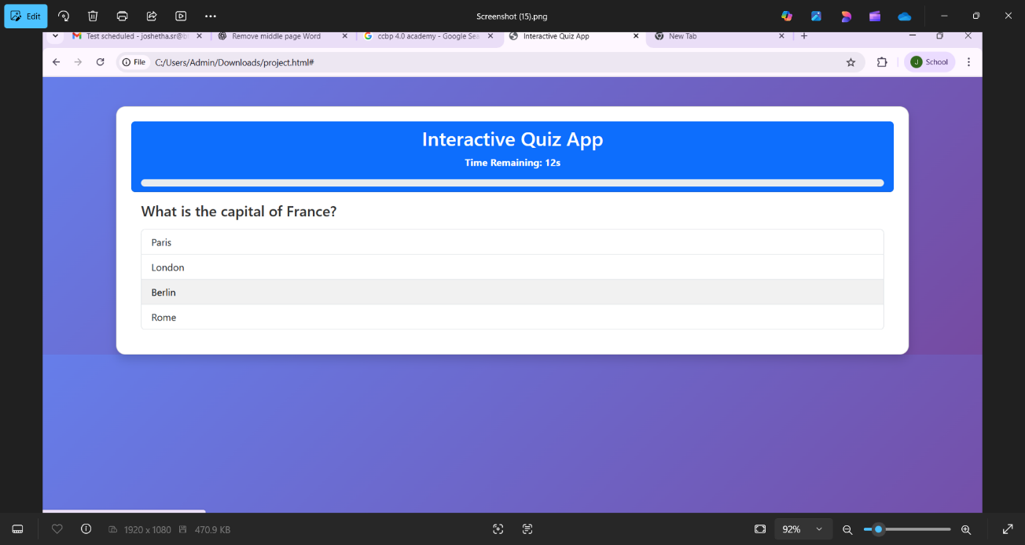

***Desktop view of the result page***

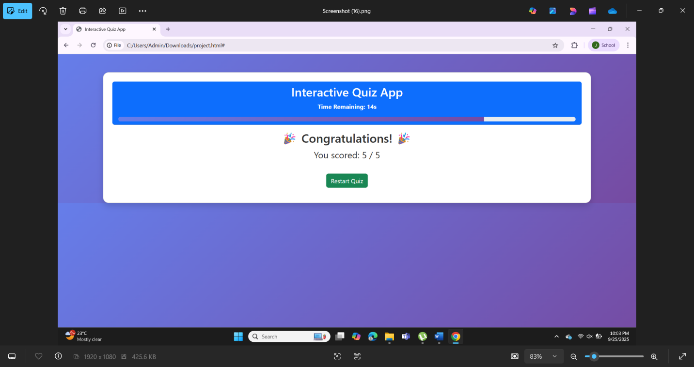

***Mobile view of the website***

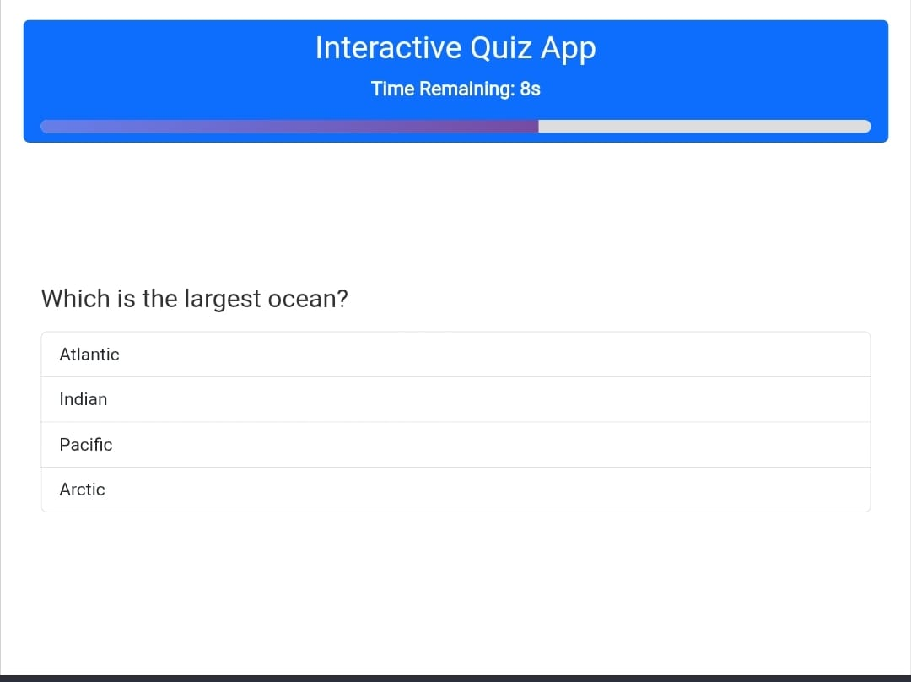

**13. Conclusion:**

The project “Interactive Quiz Application” provided hands-on experience in combining **frontend technologies (HTML, CSS, Bootstrap)** with **logic (JavaScript, jQuery)**. It demonstrated the application of UI/UX principles in designing an engaging, responsive, and functional quiz. The project enhanced my understanding of responsive layouts, user interaction, and dynamic content handling.

**14. References:**

* L&T LMS : <https://learn.lntedutech.com/Landing/MyCourse>
* Bootstrap Documentation: https://getbootstrap.com
* MDN Web Docs: https://developer.mozilla.org